

*Hydrogen Fuel: Alternative Energy*

*Nishesh Shukla*

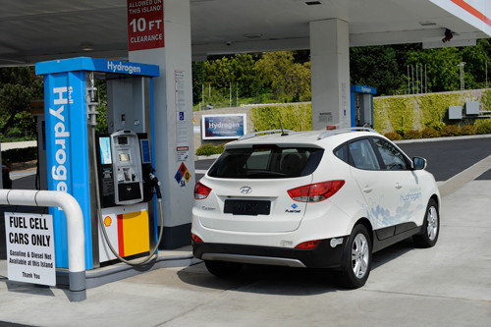**H**ydrogen can be considered as the most abundant element, making up to ¾ of the mass of the universe. In today’s world, every government and scientist is facing a nerve-wracking global crisis; shortage of fuel and the negative effects it causes for the environment (especially the ozone layer). What if we use the most abundant element in the universe as a fuel source? There wouldn’t be any shortage of hydrogen. It is an element that would survive billions of years in the future, in contrast to fossil fuels, natural gas, and nuclear power.

*Figure 1. The Universe*

*Source:* *Al-Khatib, Talal.*

In 1992, Hydrogen was considered to be an alternative fuel under the Energy Policy Act of 1992. In addition, President George W. Bush issued a $1.3 billion funding to the project in 2003. (“Alternative Fuels: Hydrogen”) Like any other renewable energy, it takes time and research to achieve an economic, zero-emission, and efficient fuel. The Hyundai Tucson Fuel Cell CUV was the outcome of the research. It is a hydrogen powered, zero-emission car available in the Los Angeles/Orange County region in the state of California, USA. Unlike current electric cars taking 8-12 hours to recharge, this automobile has a range of 265 miles with 10 minutes of refueling time. (“Alternative Fuels: Hydrogen”) Unfortunately, hydrogen fuel is a relatively new alternative fuel, leading to very few hydrogen fuel gas stations. As hydrogen fuel becomes more common, the availability of hydrogen-powered automobiles expands throughout the globe.

*Figure 2.Hydrogen fuel gas station in Orange County,*

*California.*

*Source: 2015 Hyundai Tucson Fuel Cell*

Even though it is the most abundant element, Hydrogen isn’t easy to come by. It is contained in various different compounds such as: water (H2O), hydrocarbons like methane (CH4), and various other organic matters. Hydrogen can be around three times more efficient than gasoline/petrol, but more research has to be done in order for the extraction process of hydrogen to be economical, allowing the majority of the population to have access to it. In addition Hydrogen is synthesized into a liquid which allows easy access and transfer capabilities. One kilogram of Hydrogen gas has the equivalent amount of energy as one gallon of petroleum. Liquid hydrogen then powers the fuel cells in electric automobiles; fuel cells can be viewed as an internal combustion engine in petroleum automobiles. The only emission would be warm water, H2O.

**Method 1: Solar energy and Water**

Hydrogen can be acquired through natural gas, coal, solar energy, wind, and biomass. The most efficient and emission -free 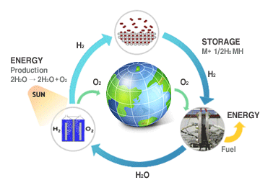procedure to acquire hydrogen is through solar energy and water. Researchers at CU Boulder developed this technique. Essentially, the sun light/rays are amplified and concentrated by mirrors to a central tower. The concentrated heat is then directed towards a chemical chamber containing metal oxides, which when heated up, release oxygen atoms. With the help of steam, acquired by boiling up water through the concentrated heat, the oxygen atoms start to stick to the surface of the metal oxides allowing the release of hydrogen atoms(see figure 3 for better understanding). Hence, hydrogen gas is acquired. However, in terms of storage, hydrogen gas requires a lot of storage space, then the hydrogen gas is converted into liquid hydrogen (it consumes less space). Liquid hydrogen can be achieved by cooling down hydrogen gas to 20.28oK (about -252.87oC). (“Hydrogen Energy”) Liquid hydrogen can then be contained in pressurized and thermally insulated containers to maintain it in its liquid form, allowing ease in transportation.

*Figure 3.It’s an endless cycle of constant renewable energy.*

*Source: Hydrogen Energy*

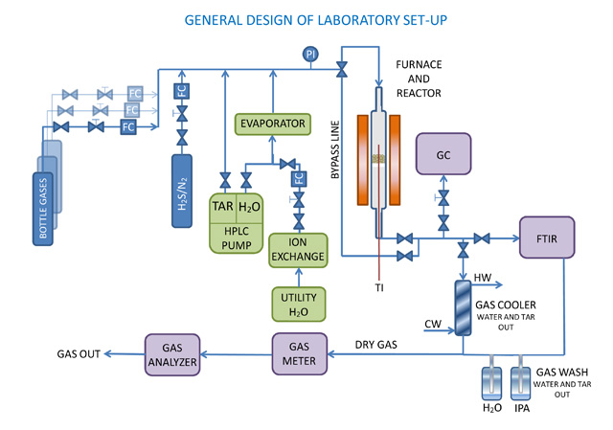**Method 2: Steam Reforming**

Nevertheless, the technique is expensive as it relies on solar energy. The most common method used to harness hydrogen gas is steam reforming. Approximately 95% of the hydrogen produced in the United States is by this method. (Al-Khatib, Talal) This method involves the usage of natural gas, such as methane, ethanol, and propane (mostly hydrocarbons). The hydrocarbons are then exposed to steam and a catalyst allowing the separation of hydrogen gas. However, natural gases are being used in the production of hydrogen gas, leading to pollutants such as Carbon Monoxide and Carbon Dioxide (See figure 4), destroying the concept of clean energy. Not only does this harm the environment and contribute to global warming, but it also increases the natural gas consumption (a non-renewable energy).

*Figure 3.Steam Reforming*

*Source: Technology for Business*

Figure 4. Equations for Methane, Propane, and Ethanol

Methane:

Propane:

Ethanol:

*Heat also plays a vital role in all these chemical equations for steam reforming.*

**Method 3: Conversion of Biomass and Wastes**  
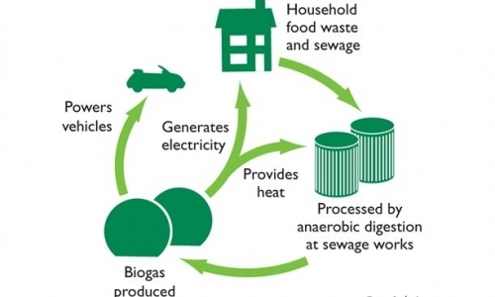One of the numerous techniques that produce hydrogen involves household wastes, called conversion of biomass and wastes. At first glance the idea, it seems to solve a lot of problems, however, it also emits greenhouse gasses that contribute to global warming. Using this technique, hydrogen gas is produced through a process called pyrolysis (gasification of biomass resources) as shown in figure 5. Biomass resources include plastics, waste grease, and agricultural wastes. It also uses biomass that is mainly grown for energy extraction purposes. During the pyrolysis process, a liquid is formed as a product that contains various different elements and compounds in form of energy, such as hydrogen gas. (Borgese, Domenic Borgese, Alexis Bianco, Tiffany Jantzen, and Andrew Ferguson.)This method has potential as it removes undesired wastes from the streets and puts it for good use. In addition, biomass is produced daily all over the globe in the form of waste and it is quite cheap to convert into energy. However, this produces various greenhouse gasses, such as Carbon Monoxide and Carbon Dioxide. Furthermore, as soon as the gasses are emitted, such as the Hydrogen gas, it is extremely difficult to capture it, as it is a quick process. Converting biomass and wastes to hydrogen gas is effective but still requires our ozone layer to pay the price.

*Figure 5. Conversion of Biomass and Wastes Cycle.*

*Source: Car is Flushed with Power*

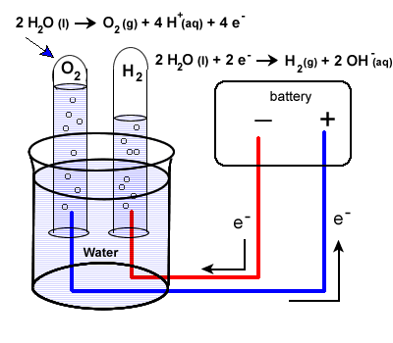**Method 4: Electrolysis**

Another method of acquiring hydrogen from water is through electrolysis. This process involves electricity (in the diagram, electricity is displayed through a battery), and water in a system called the electrolyzer. This process uses electricity to split up Hydrogen & Oxygen (see figure 6 for better understanding). It has zero greenhouse gas emission, depending on where the electricity comes from. It is a renewable energy and environmentally friendly. ("Science Unleashed - Electrolysis with Water")

*Figure 6.Small-scale experiment diagram of an electrolyzer*

*Source: Science Unleaded – Electrolysis with Water*

Despite the process of electrolysis producing no greenhouse gasses produced, whether it is completely green or not still depends on how the electricity was acquired. If electricity were acquired through a hydroelectric dam, then it would be considered a green zero-emission technique, but this method is expensive to acquire hydrogen gas on a large-scale electrolysis. If a large-scale electrolyzer were built for the production of hydrogen gas, then there would be an enormous amount of stress on the electricity grid, potentially leading to a large-scale explosion.

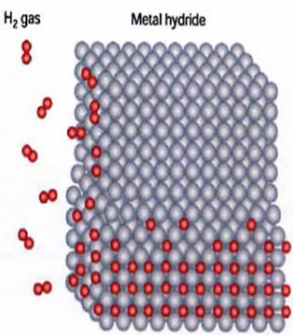Often times acquiring a renewable energy is difficult compared to storing it. Biodiesel, for example, can be stored as easily as petroleum, but in regards to hydrogen gas it is quite the opposite. Storing hydrogen gas and liquid is difficult. There are three known ways to store hydrogen fuel, solid, compression, and cryogenic.

Solid storage is achieved through combining hydrogen gas with metal hydride. Hydrogen, as a gas, can react, and wants to react with group 1 and 2 metals from the periodic table to form hydrides, making solid storage an easy triumph (shown in figure 7). Then, in order for consumer use, water is used to react with the hydride to separate hydrogen gas from metal hydride. This allows extremely low explosion risks. However, the metals are expensive, costing around $370 per pound, as well as very heavy.( Borgese, Domenic Borgese, Alexis Bianco, Tiffany Jantzen, and Andrew Ferguson) Hence, storing certain amounts of hydrogen consumes a lot of space.

Figure 7. How the hydrogen has attaches to the metal hydride.

Source: *Metal Hydrides for Hydrogen Fuel*

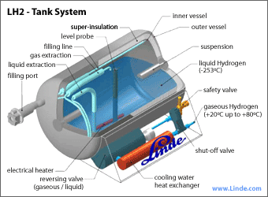Compression storage is achieved by compressing hydrogen, using a compressor, from the atmospheric pressure to a range between 5,000 and 10,000 PSI. Then it is stored in high pressure and thick tanks/containers, which increases a lot of weight and allows a small amount of hydrogen in each container. Hydrogen has the highest energy content by weight of any fuel; however, its energy content by volume is very low. Around 1kg of hydrogen gas would occupy 22.178 m3. Hence, looking at a price of $280 per pound.

The most efficient way to store hydrogen fuel is in its liquid (cryogenic) state. In order to acquire hydrogen in a liquid state it needs to be cooled down to approx. 20K (roughly -253 Celsius), which requires a lot of energy, but on the plus side it greatly reduces storage volume and allows a maximum amount of hydrogen stored in a small amount of space. In a fuel cell electric automobile, it is an ideal storage form (see figure 8). A hydrogen fuel powered automobile, can only function with hydrogen in its liquid form, thus having a tank similar to the diagram seen on figure 8.The cost for liquid storage is roughly $8 per pound, which is relatively cheap compared to other storage methods. In addition, it allows ease for transportation.

*Figure 8.Fuel tank introduced in the new Hyundai Hydrogen fuelled car.*

*Source: Hydrogen Storage*

It’s a known fact that our world is running out of petroleum and other natural non-renewable resources due to the high demand and high consumption in each country. In the United States alone, transportation accounts for 71% of U.S petroleum consumption; 40% of it was imported petroleum from foreign nations. The United States might have a few decades left of oil consumption before the reserves are empty. ("Hydrogen Fuel") Not only that, due to the constant usage of non-renewable fuels, the emissions caused by the usage significantly depleted our ozone layer. This explains the need for an alternative energy/fuel, due to the fact that as the ozone layer depletes, there would be less protection against the sun’s UV rays (these rays can lead to skin cancer). In 1992, hydrogen fuel was considered to be a very effective and possibly an alternative fuel to petroleum; however this required a lot of funding and research, which paid off in the end in the form of the Hyundai Tucson Fuel Cell CUV. It is an automobile containing a fuel cell (electric car) that is powered by liquid hydrogen. It is true that liquid hydrogen is still expensive compared to petroleum, but it is rich in terms of zero-emission, meaning 100% harm-free to our already damaged environment and ozone layer. In order to allow majority of the world’s population to have access to hydrogen fuel, scientists need to explore new ways for a more economical production of hydrogen fuel without decreasing its efficiency, as it is three times more efficient than petroleum. Hydrogen fuel is the answer to our global crisis.

*Figure 9.Hyundai Tucson Fuel Cell CUV*

*Source: 2015 Hyundai Tucson Fuel Cell*

**Writer’s Memo**

After completing my first draft of this article, I realized that I had rushed into it. It contained numerous amount of technical information with chemical equations and kinetic energy graphs. This was alarming as my target audience for my article is the general public, thus, I needed my paper to be comprehended by any person in any field of expertise. However, due to that I faced a huge issue, how can I explain the efficiency and power of hydrogen fuel without chemical equations and kinetic energy graphs? In the end I decided to have a few technical details, such as 3 equations, some percentages, and facts that I acquired through years of knowledge through my teachers in simple yet comprehensive words. In addition, I placed myself in my chemistry professor’s shoes and asked myself, “How would I explain this to a student in 9th grade?” That was the key to the simplicity of this article, I explained it as if I was the teacher explaining it to students in 9th grade.

Once I was done with my second draft, I submitted it for peer review, and acquired a few interesting responses. One of my peers suggested that I should be clear on what I am trying to get across to the audience. In addition, a bit more relative information about hydrogen fuel in the beginning of this article would allow more of a “hook” for the audience. To me that was excellent advice allowing me to re-read my whole article and make corrections and adding a few more sentences about hydrogen fuel in the first page of the article. Overall I am content with my article, as this topic has fascinated me since 2009. It was always right in front of our eyes; all we needed to do is get a good pair of prescribed eyeglasses!

Furthermore, after writing this article more questions popped into my head about the efficiency of any renewable energy. As whichever renewable energy we try to look at, the input energy (energy used to harness the renewable energy) is always going to be greater than the output energy (renewable energy). This raises a question on whether to actually pursue such energy, or just leave it and let the future generation handle it when it gets worse?

**New Writer’s Memo**

After having Dr. Dahlin review my essay, I figured out that since the beginning I’ve written my essays with the wrong citation format. Hence, I had to change my entire essay’s format to double space, and proper MLA format. Such as, including name, professor, course, and date in the header; and have the page numbers on the bottom of each page. Also, my citations had to be alphabetized and I had to reference them in the text as well. My images and diagrams were too small to read, so I increased them in size and labeled and had them cited. I also put in some keywords to reference to specific parts of the images or for the purpose I included an image in the first place.

Another main issue that was pointed out to me was my grammatical mistakes. I tend to use too many commas to avoid run-on-sentences, which still is an error. Hence, I broke them apart and made them into separate sentences. Comically, I’ve always been using “quiet” instead of “quite”. I believe I’ve been making the same mistake since 3rd grade! Sometimes having too much information makes the essay hard to ready, hence, I had to put some sub headings to allow the reader some breathing space and organization. The images as well needed some space, as they were crunched in with text. Overall, I’ve correct most of my errors; this gave me a realization that I still have a long way to go in the area of technical writing.

**Work Cited**

"2015 Hyundai Tucson Fuel Cell." *2015 Hyundai Tucson Fuel Cell | Hydrogen-Powered Vehicle | Hyundai*. N.p., n.d. Web.

Al-Khatib, Talal. "Can Hydrogen Be the Fuel of the Future?" *HowStuffWorks*.

HowStuffWorks.com, 29 Aug. 2012. Web. http://science.howstuffworks.com/environmental/energy/hydrogen-fuel-future.htm.

"Alternative Fuels: Hydrogen." *AFDC Energy*. N.p., n.d. Web. http://www.afdc.energy.gov/fuels/hydrogen.html.

Borgese, Domenic Borgese, Alexis Bianco, Tiffany Jantzen, and Andrew Ferguson. "Hydrogen Fueling Station." *PSU: Personal*. PSU, n.d. Web. http://www.personal.psu.edu/dab5475/Report.htm.

"Car Is Flushed with Power." *Wessex Water – Delivering Water and Sewerage Services within South West England*. N.p., n.d. Web.

"Health and Environmental Effects of Ozone Layer Depletion | Science | Ozone Layer Protection | US EPA." *EPA*. Environmental Protection Agency, n.d. Web.

http://www.epa.gov/spdpublc/science/effects/index.html.

"Hydrogen Energy." *Renewable Energy World*. N.p., n.d. Web. http://www.renewableenergyworld.com/rea/tech/hydrogen.

"Hydrogen Fuel." *- Energy from Reacting Hydrogen (H2) with Oxygen*. N.p., n.d. Web. http://www.alternative-energy-news.info/technology/hydrogen-fuel/.

"Hydrogen." *Fuel*. N.p., n.d. Web. http://www.fueleconomy.gov/feg/hydrogen.shtml.

"Hydrogen Storage." *Energy.gov*. N.p., n.d. Web.

"Metal Hydrides for Hydrogen Fuel." *Metal Hydrides for Hydrogen Fuel*. N.p., n.d. Web.

"Portable Water Purification." *Portable Water Purification | Filtration Systems - LIFESAVER Systems*. N.p., n.d. Web. 30 June 2014.

"Radically New Technique To Produce Hydrogen Fuel From Water." *CleanTechnica*. N.p., n.d. Web. [http://cleantechnica.com/2013/08/02/radically-new-technique-to produce-hydrogen-fuel-from-water-developed/](http://cleantechnica.com/2013/08/02/radically-new-technique-to-produce-hydrogen-fuel-from-water-developed/).

"Science Unleashed - Electrolysis with Water." *Science Unleashed - Junior Cert Science in Focus*. N.p., n.d. Web.

"Technology for Business." *VTT*. N.p., n.d. Web.

**Rubric:**

|  |  |  |  |  |
| --- | --- | --- | --- | --- |
| **Category** | **Excellent (10)** | **Good (8-9)** | **Satisfactory (6-7)** | **Needs Work (0-5)** |
| **Design Layout and Idea Organization** | Article’s content was well organized. Information presented and graphics were combined to make the article more comprehensive and simple for the general public. | Article’s content was well organized. Text and graphics were used to make the article easy to read. | A fair amount of the article was organized with graphics and information. The combination of graphics and information made it hard to read. 7 points. | Article was difficult to comprehend. Somewhat of a structure, not clear. Information and graphics were randomly placed. |
| **Research Quality** | Facts were included from reliable/valuable sources. 9 points. | Some facts were included from reliable/valuable sources | Facts were included from both reliable and unreliable sources. | Opinion was more common than facts. Little to no reliable sources. |
| **Citation**  **I am adding this aspect because it’s important.** |  |  | References are given, but no specific citation style is used. 7 points. |  |
| **Mechanics** | Grammar, spelling, punctuation, and syntax are correct. | Grammar, spelling, punctuation, and syntax are mostly correct with very few mistakes [One of your patterns is comma splices (joining two sentences with a comma). You’ll have to look closely to see the yellow bars over a few commas. Please review “comma splices” in OWL or via Google. | Some grammatical, spelling, punctuation, and syntax are correct. 7 points. | Grammar, spelling, punctuation, and syntax are mostly incorrect. No evidence of proofreading. |
| **Topic** | Writer had a very good and deep understanding of the topic. Writer conveyed the topic and his understanding in the article with ease. 10 points. | Writer had a good understanding of the topic, and conveyed it with little to no difficulty in the article. | Writer had a satisfactory understanding of the topic and had difficulties conveying it in the article | Writer had a very poor understanding of the topic and had enormous amount of difficulties conveying it in the article |
| **Writer’s Memo** | On a scale from 0-10, how thoroughly does the Writer’s Memo describe the writer’s goals, process, and reflections? | I appreciated the explanation of your processes. You are taking thoughtful action to become a better writer. You needed to discuss citation, though. 8 points. |  |  |

48/60 = 80% = B-

Dear Nishesh,

I enjoyed reading your paper about hydrogen fuel. I learned some things from you: that ¾ of the mass in the universe consists of hydrogen atoms, that CU pioneered the solar energy and water process, and that you are depressed about finding an optimum solution even as you document our movement toward a solution. I think you are a conscientious, ethical person, and I got the feeling that this paper reflected your honest quest for an energy solution. I admire that.

The content of the piece is quite good. You selected an important topic, organized the sub-topics logically, and provided evidence in the form of statistics, descriptions, and examples. The vocabulary and tone were appropriate. And some of the visuals did enhance the text. All of those things are to the good.

If you want to revise, you can bring the grade up quite a bit by simple polishing. I would be happy to go over citations and/or proofreading in a revision conference if you’d like; just email me a few possible times. Follow the revision guidelines in the syllabus. Your resubmission date (via “Revisions” in the Dropbox) would be 30 June.

Overall, this piece demonstrates your acute intelligence and ability to work with complex material. With some polishing, the other components will shine as much as the content.

Sincerely,

Dr. Dahlin